***AI VISUAL ANSWERING***

Group 6

Venkata Rachakonda

Abhishek Amin

# INTRODUCTION

Artificial intelligence (AI) has the tremendous potential to be a game-changing tool in solving complex real-world problems in today's quickly evolving technological scene. This report provides a creative AI-driven solution that combines natural language generation (NLG) with visual question-answering (VQA) techniques. The result is a comprehensive mechanism designed for image-based queries that not only provides succinct responses but also creates descriptive narratives, providing users with a flexible interface for interacting with images, posing inquiries, and accessing both succinct responses and immersive contextual elucidations.

The project's motivation arises from a profound interest in AI's capacity to connect human understanding with machines. This potential to not just decipher images but also deliver insightful answers and descriptions has the potential to revolutionize our interaction with visual information.

# PROBLEM STATEMENT

The ability to comprehend visual content and answer questions related to it is an essential aspect of human communication. This project seeks to bridge the gap between AI systems and human-like comprehension of visual data. Our AI product addresses the challenge of understanding and responding to questions about images, catering to various domains such as education, content generation, and image analysis.

This project is all about teaching computers to "see" images and answer questions about them. Just like we can look at a picture and say what is happening, we want AI to do that too. Our AI creation steps in to solve the puzzle of answering questions about images. This can be useful in many areas like schools, making content, and understanding what is in pictures.

Today, there is a flood of pictures all around us on the internet. But it is not easy for people to quickly make sense of all those images. Here comes our AI solution to the rescue. It has the potential to change the way we deal with pictures. By providing clear and detailed answers to questions about images, our tool could make using pictures more helpful for everyone. Whether you are a student, a content creator, or someone trying to understand images for work, our AI creation could give you a hand. It is like a bridge between humans and machines, helping them communicate better through images.

# LANGUAGE MODEL SELECTION

In the development of our AI product, the selection of the right language models plays a pivotal role in ensuring its accuracy and effectiveness. Our approach involves harnessing models that cater specifically to the challenges of Visual Question Answering (VQA) and text generation tasks.

1. **Specialized Model for Visual Question Answering**

The cornerstone of our language model selection is the utilization of the **dandelin/vilt-b32-finetuned-vqa** model. This model has been intricately fine-tuned for the intricate task of VQA using the ViLT (Vision-and-Language Transformer) architecture. This specialization allows the model to understand images and provide precise answers to questions about them.

The **dandelin/vilt-b32-finetuned-vqa** model has been trained to bridge the gap between text and visual information. It can process both textual questions and visual content, ensuring a comprehensive comprehension of the queries posed to it. Its architecture enables it to simultaneously grasp the context of the question and the visual context, resulting in responses that are contextually relevant and accurate.

1. **Unlocking the Potential of VQA**

By incorporating the **dandelin/vilt-b32-finetuned-vqa** model into our AI product, we've equipped it with the ability to decipher images and provide meaningful responses to inquiries about them. This empowers users to interact with images in a manner like human-like comprehension.

In the next section, we will explore the integration of the **text-davinci-002** model and how it complements the VQA model by enhancing the text generation capabilities of our AI product.

Our language model selection strategy encompasses the integration of models that cater to different aspects of our AI product's functionality. In this section, we delve into the role of the **text-davinci-002** model, which adds a new dimension to our solution.

1. **Augmenting Text Generation with text-davinci-002**
   1. The Power of Text Generation

The text-davinci-002 model, a variant of OpenAI's GPT-3, specializes in text generation tasks. This model enhances our AI product's capabilities by generating comprehensive descriptions that provide deeper insights into the context of images. It bridges the gap between visual content and textual comprehension, delivering narratives that enrich user understanding.

* 1. Seamlessly Integrating Text and Vision

Our AI product's architecture achieves a seamless blend of VQA and text generation through the collaboration of the **dandelin/vilt-b32-finetuned-vqa** and text-davinci-002 models. While the VQA model excels in precise question-answering related to images, the GPT-3-powered model contributes by generating contextual narratives that enhance the overall user experience.

1. **Synergistic Functionality**

The synergy between the specialized VQA model and the advanced text generation capabilities of the **text-davinci-002** model creates a cohesive AI product that not only answers questions about images but also provides vivid descriptions. This dual-layered approach elevates user interaction and comprehension, making our AI product a comprehensive tool for understanding and engaging with visual content.

# FINE TUNING MODEL

Fine-tune the Vision-and-Language Transformer (ViLT) for visual question answering, similarly like fine-tune BERT: - - head on top that is randomly initialized, and trains it end-to-end together with a pre-trained base.

* Labels, which is a list of integer indices of the labels that apply to a given image + question.
* scores, which are the corresponding scores (between 0 and 1), which indicate the importance of each label.

Figure

Figure

Figure

# PRODUCT DESIGN

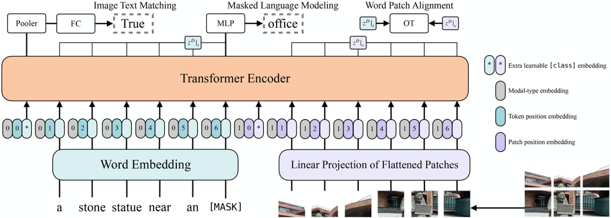

Figure

# FRONT-END APPLICATION

1. **USER INTERFACE DESIGN**

The user interface (UI) of our AI product plays a crucial role in delivering a seamless and intuitive experience to users. To achieve this, we've designed two main web pages: the login page and the Visual Question Answering (VQA) page.

* 1. Login Page (**login.html**)

The login page provides users with a secure access point to our AI application. It features a simple form where users can enter their username and password. In case of any errors, an error message is displayed in red to communicate issues effectively. This ensures a user-friendly approach to authentication.

* 1. Visual Question Answering Page (**vqa.html**)

Upon successful login, users are directed to the VQA page, where the core functionality of our AI product comes to life. The VQA page prominently displays a header indicating the purpose of the page. Inside the page, we've employed an iframe to embed the Gradio app. This integration seamlessly allows users to interact with our AI-powered Visual Question Answering system. The width and height of the iframe are set to provide a balanced and visually appealing display of the app.

By crafting these web pages, we've created an engaging front-end interface that welcomes users and facilitates their interaction with our AI product's functionalities.

User Interface

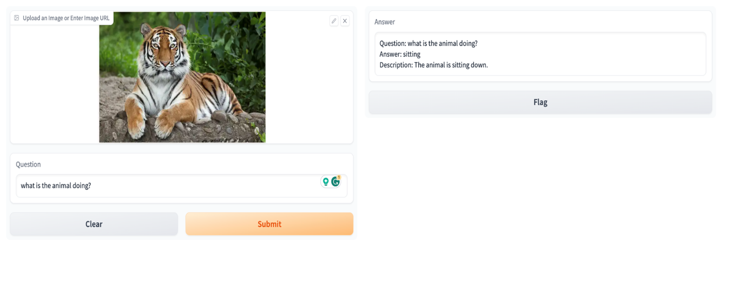

Figure

# FUNCTIONALITY

1. **Image Processing and Understanding**

* **Image Interpretation**: Users can upload images directly or provide URLs to images. Our AI processes these images to understand their content and context.
* **Visual Features Extraction**: The AI extracts key visual features from the images, identifying objects, scenes, and details that contribute to understanding.

1. **Question Analysis and Generation**

* **Question Interpretation**: Users input their questions about the images. Our AI comprehends these questions and recognizes the specific information being sought.
* **Answer Generation**: The AI's core function is to generate accurate and contextually relevant answers to the questions posed by users.

1. **Text Generation for Descriptions**

* **Contextual Descriptions**: Beyond answering questions, our AI can generate descriptive narratives that provide a broader understanding of the image's content.
* **Rich Details**: These descriptions enhance users' understanding by adding layers of context, details, and insights that go beyond straightforward answers.

# TECHNICAL EXPLANATION

1. **How Our AI Understands Images**

* **Image Processing**: Our AI takes in images that users provide or link to. It processes these images to understand what's happening in them. Imagine it's like your AI's way of "seeing."
* **Question Input**: When users ask questions about the images, our AI understands the words and figures out what they want to know. It's like the AI is listening to the user's questions.
* **Combining Visual and Textual**: The AI cleverly blends what it "sees" in the images with what it "hears" from the questions. This teamwork helps it understand and answer better.

1. **The VQA Model at Work**

* **Special Model for VQA**: We use a special model trained for Visual Question Answering (VQA). It's like having an expert that knows how to answer questions about images.
* **Finding the Right Answer**: The VQA model looks at the images and the questions. It figures out what the best answer is and gives it to us. It's like the model is playing detective to solve the question.

1. **Enhancing with Text Generation**

* **Text Generation Model**: We also have a model that's great at making stories with words. This model can take what the VQA model finds and create more details about it. It's like the AI is telling a story about the images.
* **Creating Descriptive Narratives**: The text generation model can craft descriptions that help users understand the images better. It adds a layer of information that goes beyond simple answers.

1. **How They Work Together**

* **Working Hand in Hand**: Both models, the VQA one and the text generation one, team up to give us a comprehensive result. They talk to each other to provide answers and details that make sense.
* **Answering with Depth**: The VQA model gives us straightforward answers, and the text generation model adds the extra "wow" with detailed descriptions. It's like having both a quick answer and a complete story.

# EVALUATION METRICS

Ensuring the accuracy and effectiveness of our AI product is vital.

1. **Measuring Precision**

* **Answer Accuracy**: Our AI's ability to provide accurate answers is a cornerstone. We gauge this by comparing its responses to verified correct answers for a set of questions and images.
* **Question-Answer Pairs**: A curated collection of question-answer pairs serves as our reference. We assess the percentage of correct answers given by our AI on this dataset.

1. **Contextual Cohesion**

* **Contextual Relevance**: Beyond correctness, we emphasize the importance of contextually relevant answers. Our AI's responses must align with the image and question's context.
* **Human Evaluators**: Human evaluators determine if the AI's answers fit the context. Their judgment ensures that responses resonate coherently within the given scenario.

1. **User-Centric Insight**

* **User Feedback Integration**: User input is invaluable. We incorporate user feedback to gauge user satisfaction, experience, and identify areas for enhancement.
* **Continuous Refinement**: User feedback drives iterative improvement. We refine our AI model based on user interactions to enhance accuracy and user satisfaction.

# LIMITAIONS AND ETHICAL CONSIDERATION

1. **Considerations for Responsible Use**

* **Respectful Output**: AI generates content based on patterns it learned. We ensure our outputs align with respectful and considerate communication.
* **Biased Outputs**: AI can inadvertently inherit biases from training data. We meticulously scrutinize and adjust to mitigate bias and deliver fair outcomes.

1. **Grasping the Boundaries**

* **Limited Context**: AI's comprehension is limited by the data it learned from. It might struggle in unfamiliar or complex contexts.
* **Ambiguous Interpretation**: AI may sometimes misinterpret queries or images due to inherent ambiguity.

1. **The Human-AI Partnership**

* **Human Monitoring**: We actively monitor AI's performance and outputs, stepping in to rectify potential errors.
* **Continuous Learning**: By learning from user interactions, our AI becomes more refined over time.

1. **Ethical Responsibility**

* **Avoiding Harm**: We take measures to prevent AI from causing harm, ensuring outputs adhere to ethical standards.
* **Transparent Operation**: We're transparent about AI's capabilities and limitations, promoting informed engagement.

1. **User Empowerment**

* **Informed Consent**: Users are informed of AI's involvement, allowing them to make informed choices.
* **User Control**: Users retain control over interactions, ensuring AI serves their needs.

# FUTURE ENHANCEMENTS

1. **More Diverse Answers**

* **Adding Variety**: This means more diverse responses that cover different aspects of the questions.
* **Comprehensive Insights**: Users can expect answers that delve into various dimensions, offering a richer understanding of the images.

1. **Improved Context Sensitivity**

* **Sharper Context Understanding**: Our goal is to make the AI even better at understanding the nuances of context in both questions and images.
* **Fine-Tuned Responses**: This enhancement will ensure that answers align seamlessly with the specifics of the queries.

1. **Multilingual Support**

* **Language Expansion**: The possibility of enabling our AI to understand and respond in multiple languages can be explored.
* **Global Reach**: This enhancement will make our AI accessible and useful to users from different linguistic backgrounds.

1. **Interactive Learning**

* **User-Driven Adaptation**: Our AI will learn not only from interactions but also from direct user feedback.
* **Personalized Assistance**: This will result in more personalized and tailored answers based on individual preferences.

1. **Enhanced Image Understanding**

* **Advanced Image Analysis**: Some ways to improve the AI's ability to analyze complex images, including those with intricate details.
* **Deeper Visual Insights**: Users can anticipate more detailed answers that capture subtle aspects of the images.

1. **Real-time Interaction**

* **Instantaneous Responses**: Reducing the response time even further, ensuring users get answers without any delay.
* **Seamless Engagement**: This enhancement aims to enhance the overall user experience by providing quick and efficient interactions.

# CONCLUSION

In conclusion, our AI-based image question-answering solution marks a pivotal step in merging technology with human interaction. By providing accurate answers and contextual descriptions, we're reshaping how we engage with visual content. As we refine our AI product, our commitment to responsible development and ethical considerations remains unwavering. This project showcases the potential of AI to tackle real-world challenges while emphasizing the importance of innovation and responsible implementation. Our journey reflects a dynamic fusion of AI and human collaboration, poised to leave a lasting impact in diverse sectors.